***“APTECH EDUCATION”***

***(PROJECT )***

***TOPIC NAME : HOME INTERIOR***

|  |  |  |
| --- | --- | --- |
| **FACULTY :** | **SIR TEHAMI FAISAL** | |
| **BATCH :** | **2312E, 2405A** | |
| **EPROJECT :** | **HOME INTERIOR** | |
| **S. NO.** | **ENROLLMENT NO.** | **STUDENT NAME.** |
| **1.** | * **1536847** | **M. AHSAN KHAN** |
| **2.** | * **1500757** | **M.SAMI** |
| **3.** | * **1561236** | **NARJIS ZEHRA** |
| **4.** | * **1547428** | **SHAYAN ALAM** |
| **5.** | * **1556474** | **MUHAMMAD AMMAN** |

***CONTENT***

|  |  |  |
| --- | --- | --- |
| *SR:NO* | *TOPICS* | *Pg:no* |
| 01 | ***Home Interior introduction*** | **1** |
| 02 | ***(Purpose) AND (Scope)*** | **2** |
| 03 | ***Home*** | **3** |
| 04 | ***Products*** | **4** |
| 05 | ***About us*** | **5** |
| 06 | ***Contact us*** | **6** |
| 07 | ***Gallery*** | **7** |
| 08 | ***Feedback*** | **8** |

***HOME-INTERIOR***

***Introduction:***

*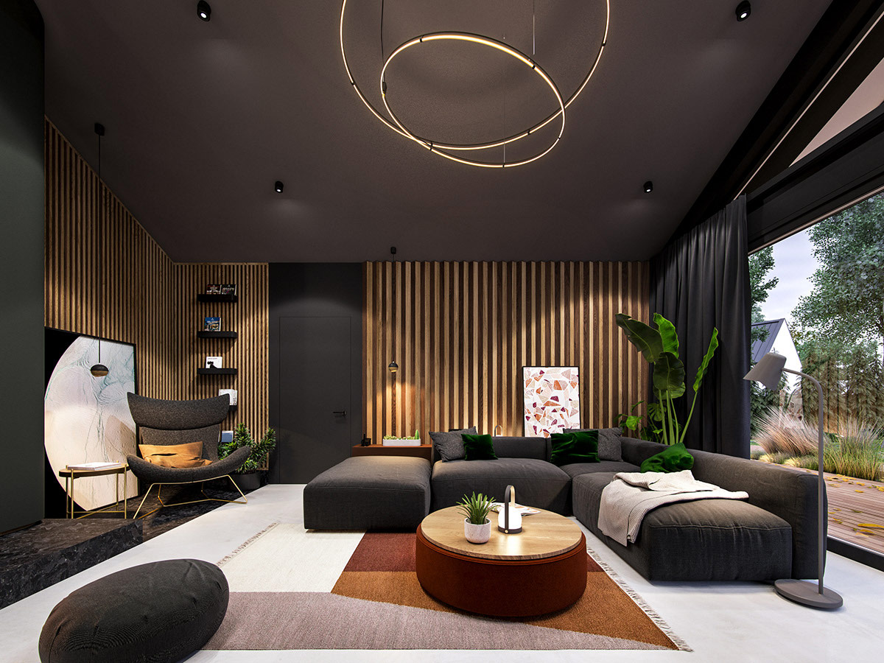Residential home interior design focuses on enhancing the interior spaces of homes to create an aesthetically pleasing and functional environment. This includes choosing color schemes, furniture lighting , and decor that reflect the homeowners personal styles while maximizing the spaces efficiency and comfort. Bassically, interior design is about ensuring that a room, such as a kitchen, serves all of its intended purposes while at the same time creating an aesthetic that appeals to people. It creates a positive and healthy response to those who will be using or living in the space.*

***Purpose:***

*Good interior design plays an important role in creating a comfortable loving or working environment. A well-designed space can greatly enhance the overall comfort and satisfaction of its occupants. Choosing the right ligtning is one of the most important factors in ensuring a sense of calm and positive energy in a space.*

***Scope:***

1. *Determining the layout of furniture and other elements to optimize the use of space.*
2. *Selecting colors that complement each other and create the desired ambiance in different rooms.*
3. *Choosing furniture that fits the space, is comfortable, and aligns with the overall design theme.*
4. *Selecting decor items such as artwork, rugs, curtains and plants to personalize the space and add characters.*

***HOME:***

**Description**

*Home interior design is an identity that gives your home a special atmosphere and look. It makes every corner of your home lively and beautiful. When planning the interior design of your home.*

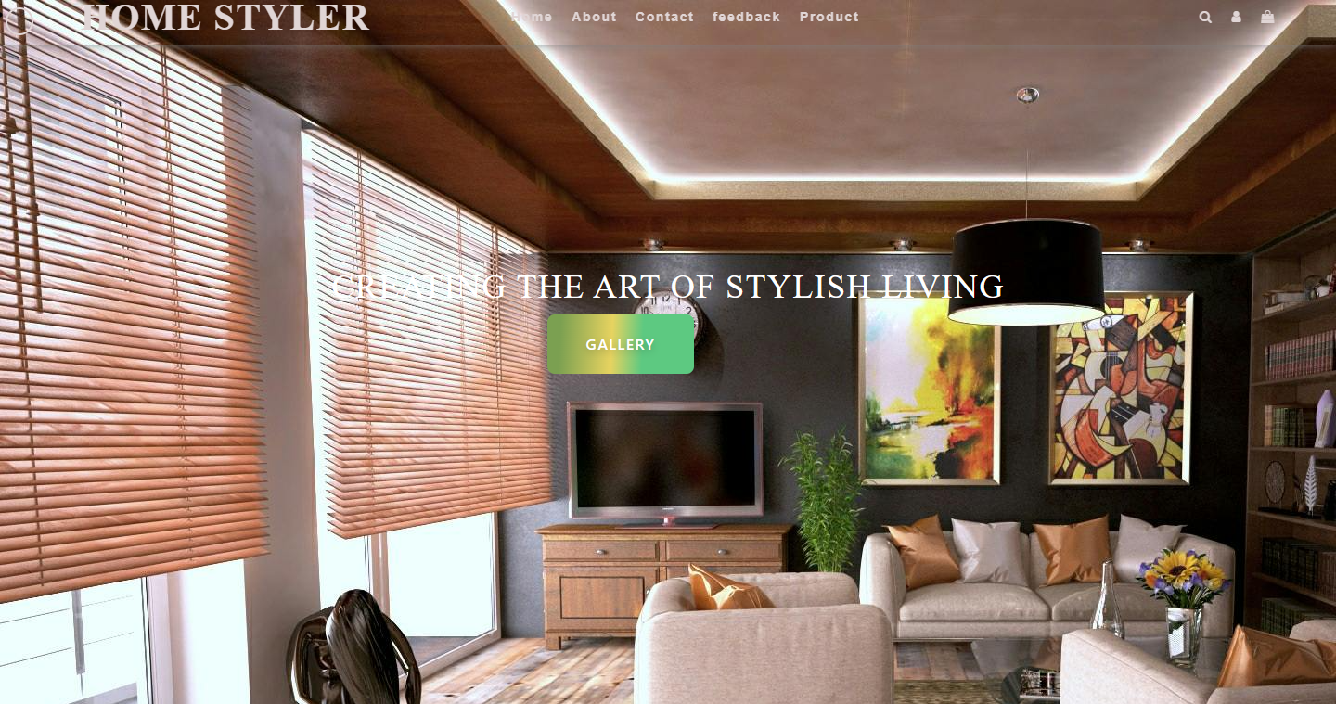

**Features**

*The features of home interior design includes:*

1. *Selecting the right color pallete is crucial in setting the mood and ambiance of a room. Different colors can evoke different emotions and affect the perception of space.*
2. *Choosing furniture that not only fits the space but also complements the overall design theme. The furniture should be comfortable, functional and aesthetically pleasing.*
3. *Lighting plays a significant role in enhancing the atmosphere of a room. Properly planned lighting can highlight architectural features, create focal points, and provide adequate illumination for various activities.*

**Navigation**

*Navigation in home interior deign involves understanding how different elements work together to create a cohensive and harmonious living space. After understanding these features and navigation through the design process, you can create a home interior that is both functional and visually appealing.*

***ABOUT:***

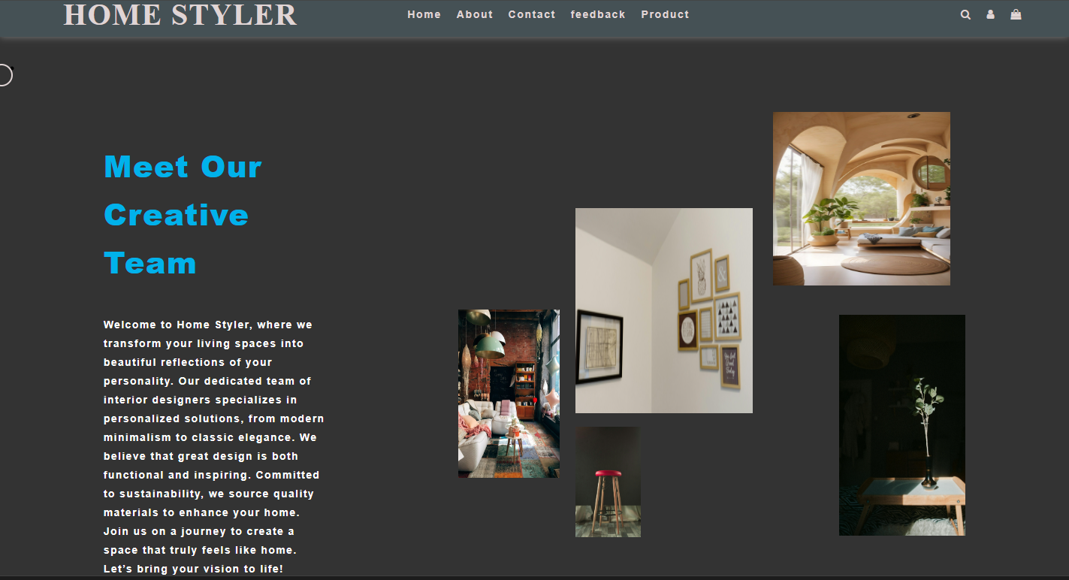

Overview

*The About section introduces our home interior, our products, and the team behind it. It establishes a connection with the customers and emphasizes the project's commitment to promoting our interior designs.*

Our services

*We are clearly defined our service.*

***PRODUCTS:***

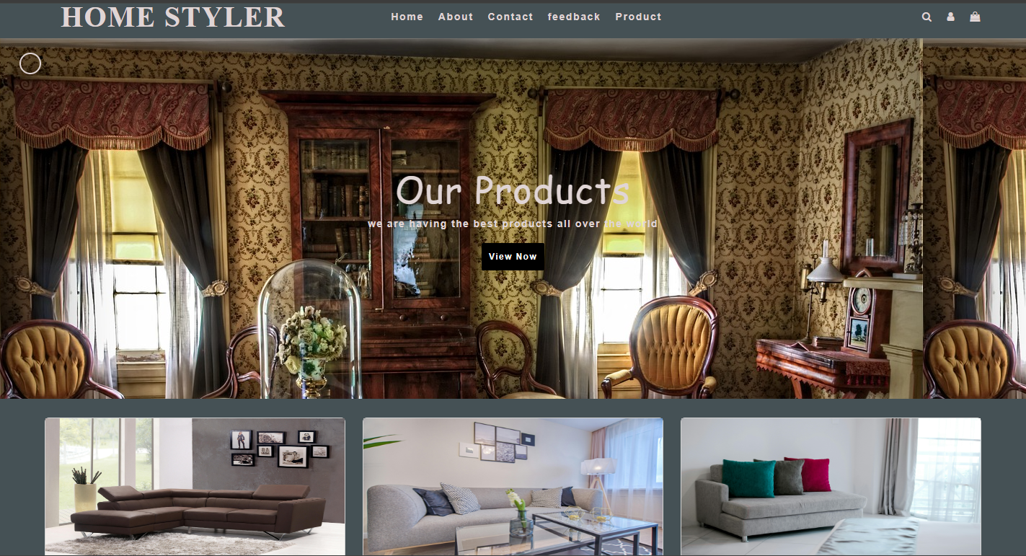

**Overview**

*Introducing the importance of home interior design in creating a welcoming and aesthetically pleasing living space. Discuss how interior design influences the mood, functionality, and overall ambiance of a home.*

**Research Inspiration**

*Conduct research on current design trends, styles and themes that resonate with your personal taste and vision for your home. Gather inspiration from interior design magazines, websites, social media platforms likes pinterest, or Instagram and even by visiting furniture stores or showrooms.*

**Space Analysis**

*Analyse the available space in your home, considering the layout, dimension, and natural light sources. Identify the focal points of each room and assess how you can maximize the use of space while maintaining a harmonious flow throughout the house.*

**Design Concept**

*Develop design concept based on our research and space analysis. Consider elements such as color, schemes, furniture styles, lighting options, textures, and decorative accents. Create mood boards or sketches to visualize how different design elements will come together to achieve the desired look and feel for each room.*

***gallEry***

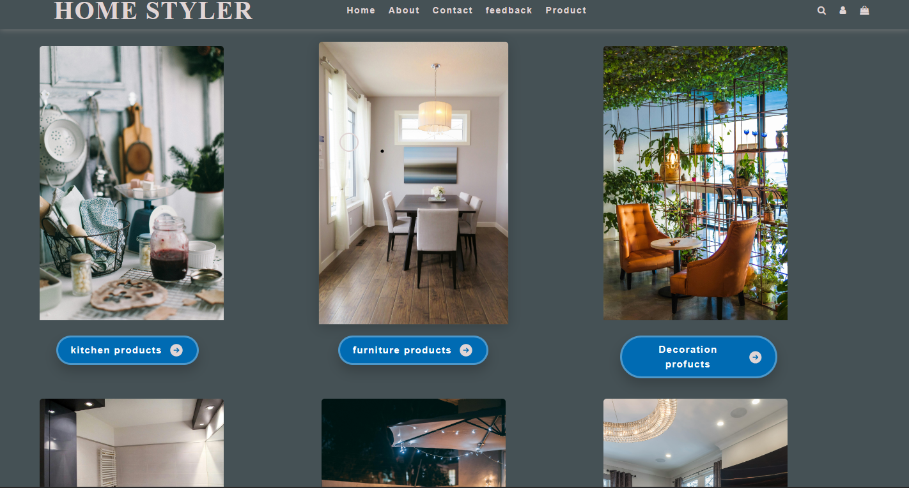

### ***Exhibition of Artwork:***

### *Exhibiting artwork in home interior design adds a unique touch and personality to the space. When showcasing artwork, considers factor like the size of the artwork, the rooms layout, and the existing decor. Lighting plays a crucial role in highlighting artwork, so consider using spotlights or picture lights to enhance the display.*

### ***Sorting and Effecting:***

* *Arranging items in home interior design in essential for creating a cohensive and visually appealing space. Start by delucttering and organizing items based on functionality and aesthetics. It can optimize space and create a harmonious environment.*

### ***Customers Request:***

* *Customer request for home interior design, its important to listen attentively to their preferences, needs, and budget. Understand their styles, color preferences, and desired functionality for each space. Provide design options, mood boards, and samples to help them updated throughout the design process and to be open to feedback and revisions.*

***Sailing:***

* *Focus on showcasing the unique features, quality, and benefits for your offerings. Create visually appealing displays, use high quality images on online platforms, and highlight customer review and testimonials. Provide excellent customer service, offer customization options, and ensure a seamless purchasing process. Building trust with your customer and estabilishing a strong bond reputation are crucial key to successful sales in the home interior industry.*

***Feedback***

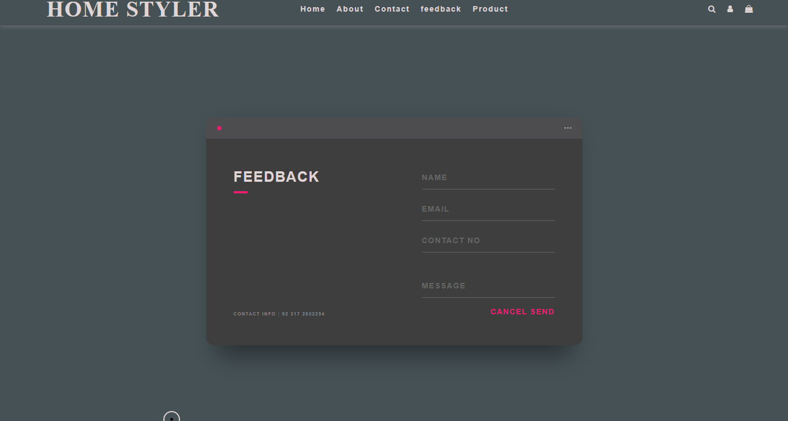

***Customers Feedback***

* *Its helps you understand how your customer are liking your services and what additional services or arrangements you can provide to meet their preferences.*

***Applause***

* *Showcasing positive compliments from customers.*

***Continuous Improvement***

* *How customers feedback is used to increase the platform****.***

***Contact us***

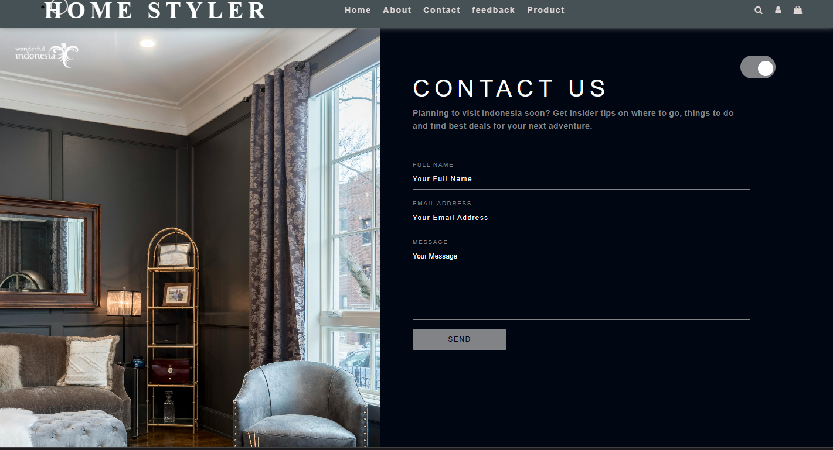

***Contact Information***

* *Users can easily communicate***.**

***Support Channels***

* + - *Information is available to our customers on support channels.*
    - *Social Media*
* *Our links are available on our social media profiles.*

***Conclusion***

*Residential home interior design focuses on enhancing the interior spaces of homes to create an aesthetically pleasing and functional environment. This includes choosing color schemes, furniture lighting , and décor that reflect the homeowners personal styles while maximizing the spaces efficiency and comfort. Good interior design plays an important role in creating a comfortable loving or working environment. Choosing the right ligtning is one of the most important factors in ensuring a sense of calm and positive energy in a space. Choosing furniture that fits the space, is comfortable, and aligns with the overall design themes. Selecting décor items such as artwork, rugs, curtains and plants to personalize the space and add characters. Choosing the right ligtning is one of the most important factors in ensuring a sense of calm and positive energy in a space.*